**Strategy Document: MarkIt**

**Sign-off matrix:**

|  |  |  |
| --- | --- | --- |
| **Name** | **Team / Role** | **Date** |
| Roni Antonius Sinabutar | Assistant BI Analyst | Aug 01, 2024 |

**Proposer:** Alice Shi, Vice President of Sales; Matías Sosa, Program Manager

**Status:** Draft > Under review > Implemented | Not implemented

**Primary dataset:** **Awaiting delivery**

## User Profiles: Used internally by the team members (Ariana Tirado, Data Warehousing Specialist; Cornelia Vega, Manager, Data Governance; Sam Winters, Data Analyst) to deliver insights to executives

# **Dashboard Functionality**

|  |  |
| --- | --- |
| **Dashboard Feature** | **Your Request** |
| Reference dashboard  (Should this dashboard be modeled on an existing dashboard? If so, provide a link and describe the similarity.) | N/A |
| Access  (How should access to the dashboard be limited? Who needs to have access?) | No information listed, ask follow-up question |
| Scope  (What data should be included or excluded in this dashboard?) | Include:   * Number of listings posted * Number of sales completed * Number of listings deleted on a daily, quarterly, and yearly timescale * How much time do users spend on the site? * What pages do they spend the most time on? * How do buyers conduct searchers and how do sellers create and maintain listings? * How do buyers and sellers contact one another? |
| Date filters and granularity  (Should the dashboard include date filters? If so, what time frame should be displayed by default? Should the dashboard include a “granularity” drop-down? If so, what granularity should be selected by default?) | Should include daily, quarterly, and yearly timescales |

# **Metrics and Charts**

Create a table for each chart that you’d like to include in the dashboard. If you’d like to break the dashboard under different headers, feel free to list those here as well.

### Will need clarification, ask follow up questions

### Chart 1

|  |  |
| --- | --- |
| **Chart Feature** | **Your Request** |
| Chart title | **TBD** |
| Chart type  (What type of chart needs to be created?) | Bar chart? |
| Dimension(s)  (What dimensions does this chart need to include?) | Listings posted (by customer ID/username) |
| Metric(s)  (What metrics are relevant to this chart?) | Number of total listings  Number of sales completed  Number of listings deleted |

### Chart 2

|  |  |
| --- | --- |
| **Chart Feature** | **Your Request** |
| Chart title | **TBD** |
| Chart type  (What type of chart needs to be created?) | Bar chart |
| Dimension(s)  (What dimensions does this chart need to include?) | Pages of the site |
| Metric(s)  (What metrics are relevant to this chart?) | Time users spend on the site/each page |

### Chart 3

|  |  |
| --- | --- |
| **Chart Feature** | **Your Request** |
| Chart title | **TBD** |
| Chart type  (What type of chart needs to be created?) | **TBD** |
| Dimension(s)  (What dimensions does this chart need to include?) | * Most popular search queries * Most popular listing types * Types of contact (email, instant message, phone call) |
| Metric(s)  (What metrics are relevant to this chart?) | Counts for most popular queries, listing types, and types of contact |

### Dashboard mockup

[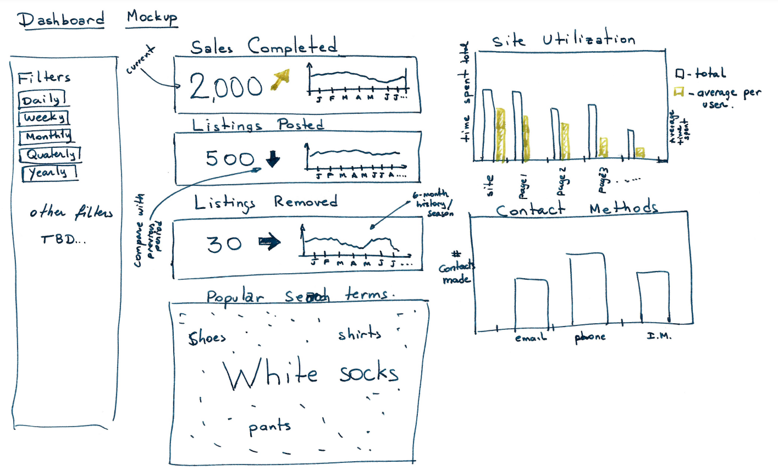](https://drive.google.com/file/d/15rZFeQtZgNXt9FgIs1WbG-TIVJxuVC8b/view?usp=sharing&resourcekey=0-IpMTA2gMAobWimPL7KYozg)

Alt text: Dashboard mockup with time filters, sales completed, listings posted/removed, search terms, site use, contact methods